CMPT481 Low-Fidelity Report

IDK PRO

Gong Cheng

Kasey Gillespie

Kaitlyn Gorsalitz

Halle Jackson

CMPT481 Low-Fidelity Report

|  |  |  |  |
| --- | --- | --- | --- |
| **Gong Cheng**  U of S  Saskatoon, Canada  goc558@mail.usask.ca | **Kasey Gillespie**  U of S  Saskatoon, Canada  kag258@mail.usask.ca | **Kaitlyn Gorsalitz**  U of S  Saskatoon, Canada  krg028@mail.usask.ca | **Halle Jackson**  U of S  Saskatoon, Canada  hsj294@mail.usask.ca |

# FUNCTIONALITY

Our app is a redesigned version of www.[deviantart.com](http://www.deviantart.com) which is an arts sharing website. It realizes arts sharing by allowing users to create an account, upload pictures of art, view other users’ art, like other users’ art, and follow other users. We put great efforts into making the arts sharing experience on devianart as enjoyable as possible by radically changing the current interaction model.

# Prototype

**Overview**

We adopted paper prototype method to do our low fidelity evaluation. To do this we have three essential ‘views’ in the prototype, the first is the browsing few which is the big sheet of paper with rectangles drawn out and some sticky tabs. We limited the number of inter actable parts to simplify the prototype. The second view is the queue view, which is placed over top of the browsing view as it acts as the sidebar and the header where the search information is displayed. Our final piece is the viewing area for art. This can be changed to work for the queue view or for viewing a single piece by adding or removing the left and right arrows. When in single view, the largest of the colored paper pieces is placed in the white space about the artist information; when in queue view, the pieces of colored paper are laid out to have a domino effect, with the smaller pieces lying beneath a larger one to show the other pieces next or back in the queue. We used the colored paper to represent drawings that the user could browse for.

**Reflections**

We had an initial meeting to discuss the design, and each of us came to the meeting with different scribble sketches of individual ideas. We presented our own ideas the other teammates one by one by explaining our sketches and answering questions about them. After all ideas were demonstrated, we discussed each one’s pros and cons. There were roughly 8 main concepts tossed around. After around two hours of discussion we combined ideas from multiple approaches and determined that our design would involve a queue sidebar that different works could be added to and removed from, the question was how would the art be added. Two main concepts were talked about:

1. The “Bubble Up” approach. The works on the main browsing screen would not remain static for a user to scroll through, and instead new art thumbnails would constantly be animating up in a revolving view. The user would pick works to add to the queue by clicking on the thumbnail, which would “pop” the “bubble” and add it to the queue, removing the thumbnail from the revolving view. [See Appendix A1]
2. A simpler approach. Each thumbnail in the main browsing screen would have a “+” button on it that, when clicked, would add that piece to the view and change the button to a “-”. [See Appendix A2]

The second approach was chosen, as the first was deemed too difficult to pursue and potentially irritating to the user. Once that was chosen a full design for all screens based on the concept and scribble sketches was drawn out on a whiteboard by one member, while the other teammates pitched in with feedback. From there the prototype was created.

We decided on a fairly limited scope for the prototype, focusing on the main tasks of adding art to a browsing queue, and viewing the art after, or viewing it in single mode. There were several screens discussed and designed that were not implemented in the prototype. One was a history screen that was determined to be similar enough to the main browsing screen that it was unnecessary to prototype. Another was a more advanced search option that was decidedly out of the scope we determined.

**USABILITY INSPECTION**

**Inspection method**

We went with the Heuristic Evaluation method for our usability inspection, because it is what our members are the most familiar with, works well with a group of our size, and is holistic. A Heuristic Evaluation, using heuristic guidelines to evaluate the usability of strict paths through the product, fit well with the scope of our prototype. As well, the initial individual approach of a heuristic evaluation fit more with our schedules at the time than a group inspection like the Formal Usability Inspection.

## Task

* View art in single view
* Add art to queue, remove art from queue, and view art queue

**Inspection Process**

The inspection was conducted individually by all four teammates, as 3-5 people are recommended for a heuristic evaluation. Two major tasks were identified as being the most basic or most important in terms of user experience for the site. Then we each set aside about an hour and walked through both tasks individually using the paper prototype while referencing the ten heuristic evaluation. We tried our best to approach the task as a first time user and to be very picky so that any potential flaw could be captured. We each wrote up the usability issues we discovered, and then came together to discuss them as a group. We amalgamated the remarks into a list and ranked them by severity. There were several items that were less issues and more discussion topics, but we left them in our combined evaluation with the severity of 0 so that we would have a record of the items discussed. To determine the severity, we talked over what we each thought it was, and then decided on it as a group.

**Results of inspection**

* There is no way of tracking what works in the queue that you have already viewed if you leave the queue and return to browsing view.
* The close button (“X”) in the art viewing screens is not that visible, and may lead users to believe that we are just closing certain sections of the view, not all of it.
* There is no way to transition from Queue View to Single View if one wants to focus more on a specific piece.
* The “add to favorites” and “remove from queue” buttons are on top of the thumbnails in the Browsing View, but to the side of the thumbnails in the Queue List, making for an inconsistent appearance.
* The Queue List is taking up a lot of space that could be better used.
* There is no option for clearing all works out of the queue, which could lead to a potentially frustrating user experience.
* Some section titles such as “Also liked” and “Other works” have meanings that are not immediately obvious
* In Browsing View, if a work was added to the queue it does not pop out, and should be more obvious.
* The arrows to move to different works in the Queue View may be extraneous and unnecessary.
* An empty queue is potentially confusing, and should instead inspire users to add to it.
* A user is not able to remove art from queue while in Queue View. This would be helpful if a user is looking through other art as a reference, and decided there were a few they were done with and wanted to remove.
* A user who has no interest in the Queue List should be able to collapse it.

**REDESIGN**

Going through our different tasks helped to inform us of how different users may go through the system, which in turn led our redesign conversation. Going over our amalgamated evaluation list, we highlighted several things we will need to modify or add in the Medium Fidelity stage.

* We will add a way of indicating which works have already been viewed in the current queue if the user goes back to browsing mode by adjusting the thumbnail.
* The close “X” button in Single View/Queue View will be moved to make it more obviously associated with the whole overlay, and more visible.
* The Queue List section will be reorganized so that the thumbnails of queued works will match how the thumbnails are displayed in the other sections.
* A “Clear All” option will be added to the Queue List.
* Many small text changes to make the intent of different sections more obvious, i.e. “Other works” to “Artist’s other works”.
* The thumbnail, or the “add to queue” and “remove from queue” buttons on a thumbnail, will be modified as to be more obvious at a glance if a work was already added to the queue.
* The browsing view will be paginated, and need some indicator of this pagination.
* When the Queue List is empty we will add a message encouraging users to add to it.
* Proportions and spacing will change in the Individual View or Queue View to better highlight main piece shown.
* We will add a way to remove art from the queue when in Queue View.
* Information as to what the Queue List is will be added as help documentation in some non-obtrusive way, for users who don’t understand it.

**Appendix A1 – A6: The sketches made to prepare the paper prototype**

**Appendix A1**

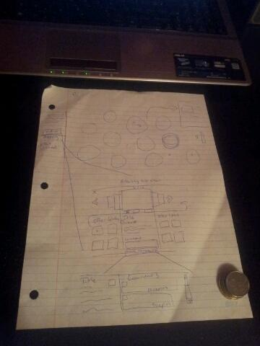

**Appendix A2**

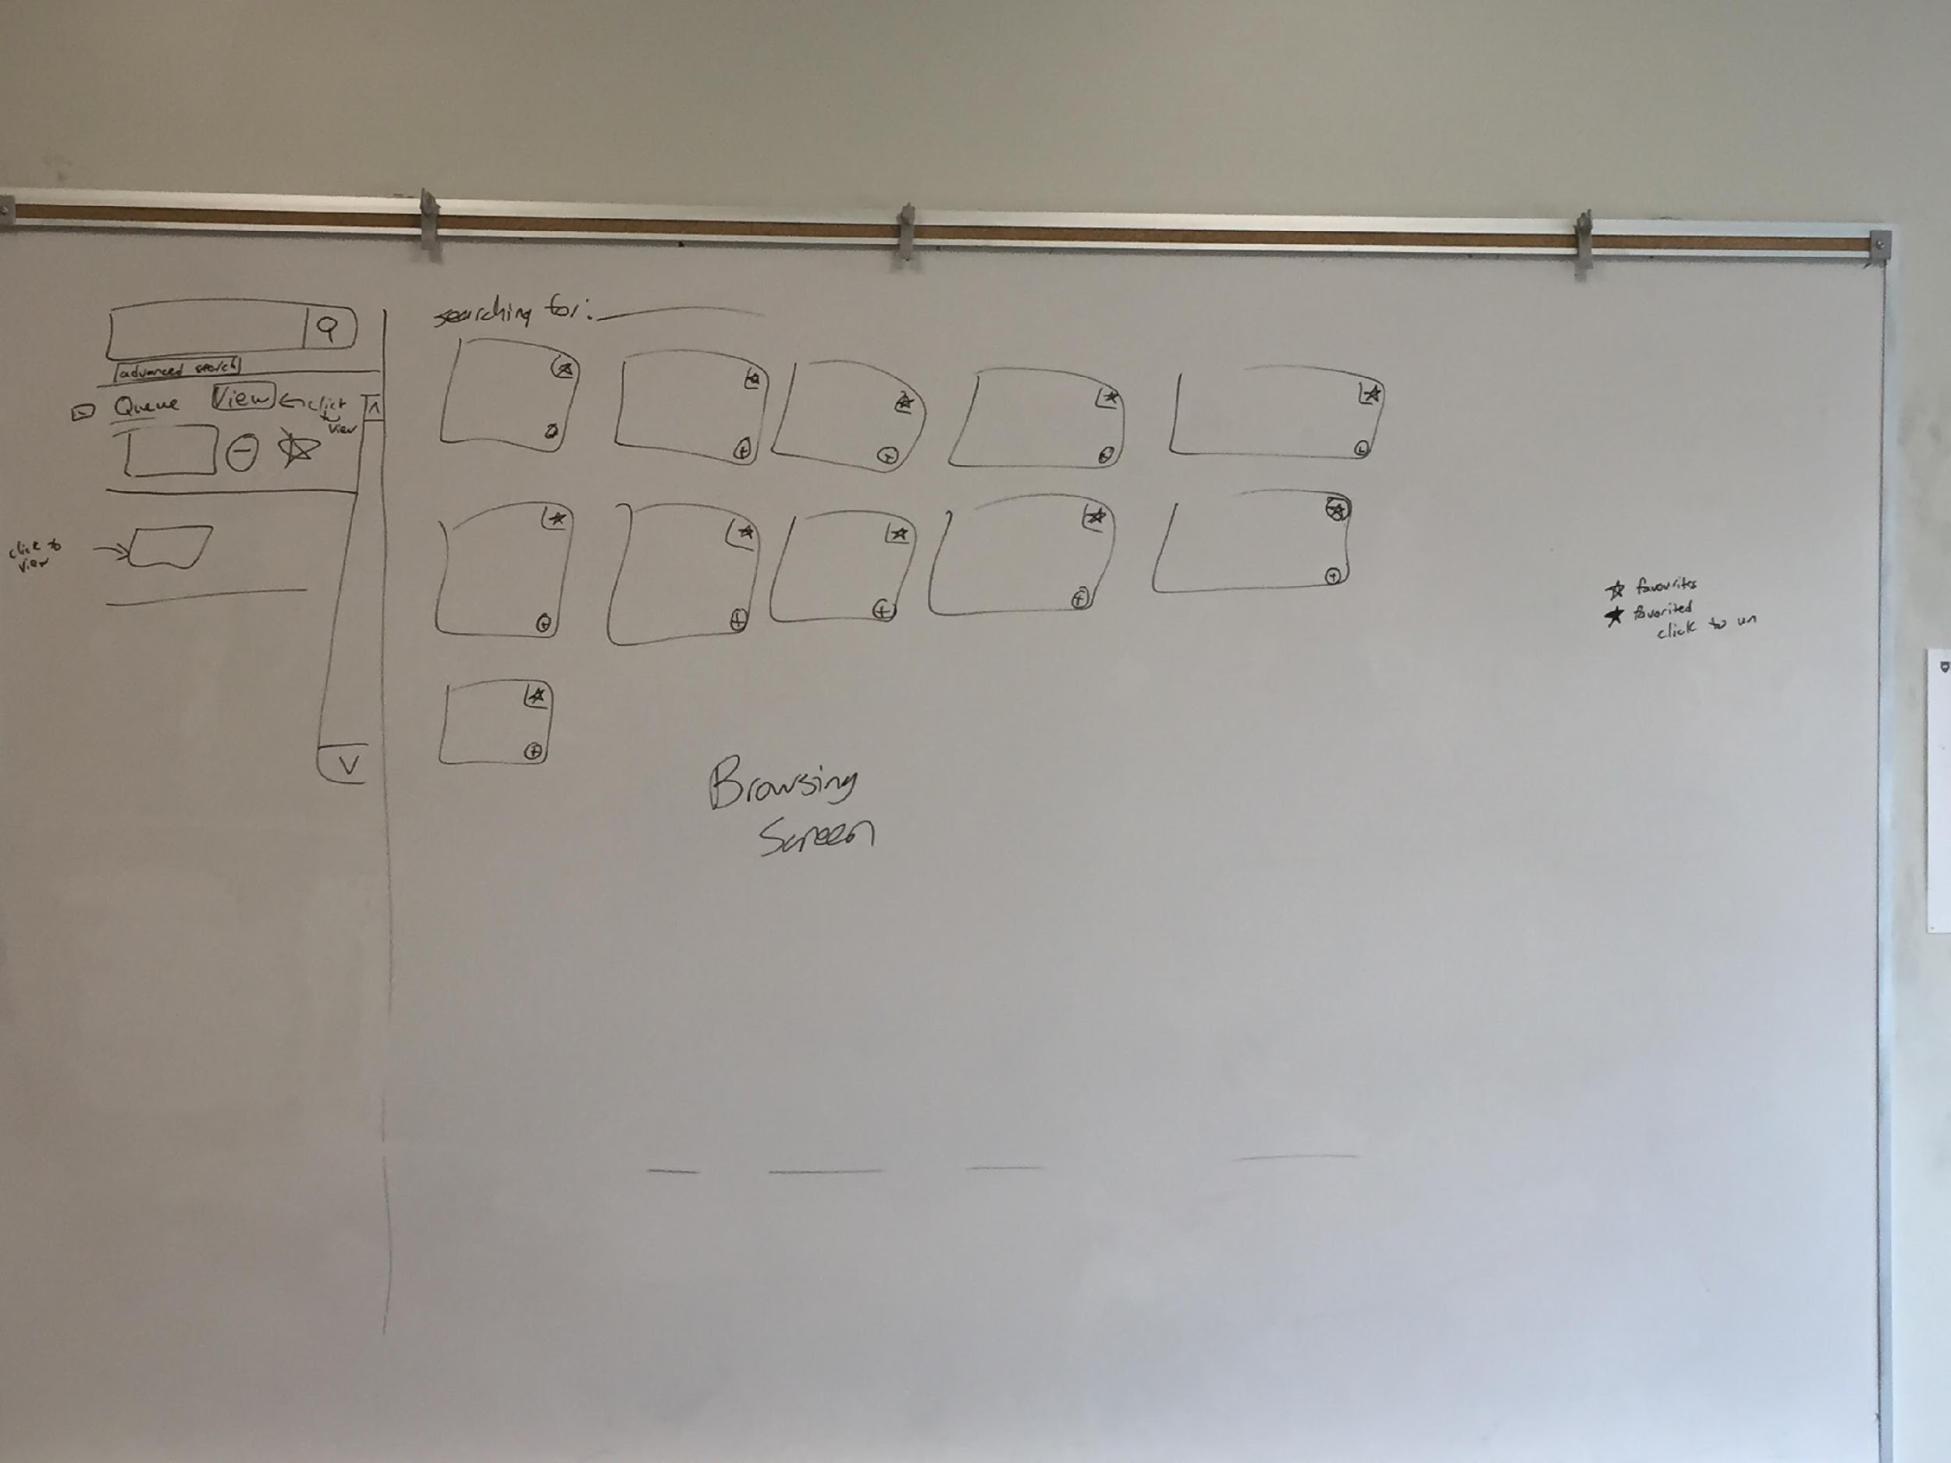

**Appendix A3**

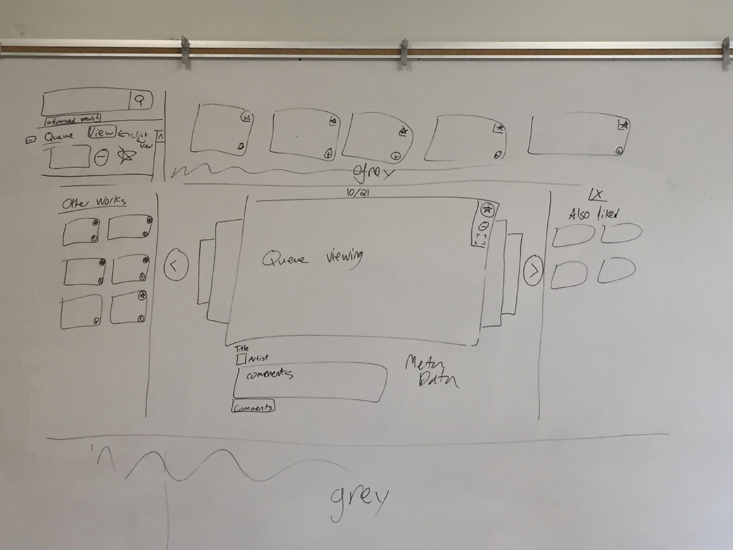

**Appendix A4**

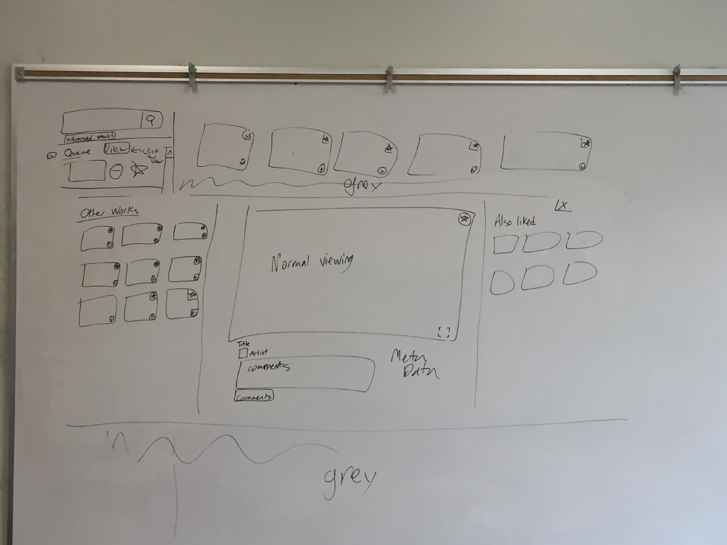

**Appendix B: Amalgamated Heuristics**

Browsing View - The main view, showing multiple works of art.

Queue List - The sidebar included in browsing view.

Queue View - The view showing specific art in queue form.

Individual View - The view showing an individual piece of art.

|  |  |  |  |
| --- | --- | --- | --- |
| Location | Heuristic | Severity (0-4) | Description |
| Individual View & Queue View | H2-1 | 0 | Individual View and Queue View are similar, which would possibly be confusing for people with no prior experience of using the website.  > We have decided this is not an issue as it keeps the views consistent and standard. |
| Individual View & Queue View | H2-2 | 0 | The Individual View/Queue View art is missing the favorite button & the comments button.  (Missing as not the focus of prototype) |
| Queue List | H2-2 | 1 | The favorite icon is missing from works in the queue. (Planned but missing in prototype).  > Added to prototype |
| Individual View/Queue View | H2-4 | 1 | The queue view column is replaced by “other works” view when switching from browsing view to queue view.  > Remain as is, queue is part of the shadowed background. |
| Browsing View | H2-6 | 2 | There is no way of tracking pictures in the queue that have already been viewed if you leave the queue.  > Thumbnail or thumbnail border will be darker if art was previously viewed in queue. |
| Individual View & Queue View | H2-7 | 1 | The close button (“X”) is not that visible in the prototype.  > Button will be moved to outside of Single View/Queue view section, and be more obvious with color. |
| Individual View & Queue View | H2-7 | 2 | No obvious way to go to single view page from queue view page. |
| Browsing View | H2-4/H2-8 | 1 | The add to/remove from queue and favorites button are in a different spot in thumbnails in queue and main browsing view. Also there is a lot of whitespace in queue.  > Buttons will be laid on top of thumbnail in queue to match how they are laid on top of thumbnail in main browsing view. |
| Queue List | H2-7/H2-3 | 3 | No option for removing all from queue  > Clear queue option will be added. |
| Individual View & Queue View | H2-3 | 2 | Paper prototype makes it hard to show that a user can add items to their queue from the ‘Other works’ and ‘Also liked’ Sections  > ‘Other works’ and  ‘Also liked’  thumbnails will have the “add to queue”/”remove from queue” buttons in the Medium Fidelity Prototype |
| Queue View | H2-3 | 0 | It is not clear if the back or forward arrow will still appear when the user is at the end or beginning of the list. Will we allow for jumping to the head/tail?  > Queue view will loop, so clicking next from the last work will take user to first work |
| Queue List | H2-8 | 0 | Border lines are present between the items in the queue. Remove in medium prototype. |
| Individual View & Queue View | H2-4 | 1 | “Also liked” doesn’t fit with DA’s terminology of “favoriting”.  > Change to “Others favorited” |
| Browsing View | H2-4 | 1 | “Searching for: [word]” and “related tags” may not be immediately apparent. Could word as “Searching for tag [word]” or “related searches” instead? |
| Individual View & Queue View | H2-5 | 2 | The X to get out of the view almost looks like an option to close just the “also liked” portion since it’s in the same area. Not obvious it’s for all view.  > Move X to outside Individual View/Queue View area. Clicking outside the area closes it as well. |
| Browsing View & Queue List | H2-5 | 1 | The + and - queue buttons should be different colors to make it easier to tell them apart.  > Button colors will be changed |
| Browsing View | H2-5/H2-6 | 1 | The +/- buttons could be bigger - it could end up easy to go into the individual view rather than add/remove the picture from the queue. A border around works added to the queue could also help?  > Border may be added |
| Browsing View & Queue List | H2-6 | 0 | There’s no scrollbar to indicate where the user is amidst the viewed works. (Already planned out, missing in prototype) |
| Browsing View | H2-7 | 0 | Is the system infinite scroll or will it go by a page by page system? Nothing shows that in the prototype.  > Page by page |
| Queue List & Queue View | H2-7 | 0 | Does the “view” button for the queue ALWAYS start at the first entry? Should there by “view” buttons for each entry to start there?  > Clicking on the image thumbnail in the Queue List will open it as the first in the Queue View |
| Queue View | H2-8 | 1 | Arrows become redundant as the thumbnails of previous/following works are shown and the users could just click those instead (and in addition skip ahead/back more than just one)  > Potentially removing arrows, or adding them on top of works in the background. |
| Queue List | H2-10 | 2 | A button such as “what is this?” or even just “?” could be good in the queue list area so people could click it if they need to know how to use the queue. Information button.  > Queue info icon or tooltip will be added |
| Queue List | H2-10 | 1/2 | When the queue is empty, in its space it could perhaps have the message “Press the + button on any piece you like to add it to this queue to make a more personalized viewing experience!” Otherwise plus button not entirely clear that it corresponds to the queue.  > Message will be added to empty queue area, encouraging users to add works to it |
| Browsing View | H2-2/H2-3 | 0 | We’ve talked about clicking to add to queue, but would drag and drop work as well?  > Yes but out of scope for prototype |
| Queue List & Queue View | H2-1/H2-4 | 1 | # of items in queue not visible in Queue List, while they are in Queue View  > Number of items in Queue List will be added |
| Individual View | H2-1 | 1 | “Other works” wording not entirely clear  > Text change to “Artist’s Other Works” |
| Individual View & Queue View | H2-8 | 1 | More focus should given to main art piece, smaller thumbnails.  > Smaller thumbnails, less white space. Measurements are off in low fidelity prototypes. |
| Queue View | H2-3 | 0 | Can you scroll through art in queue horizontally?  > Yes, but it’s potentially out of scope for the medium fidelity prototype |
| Queue View | H2-1 | 0 | # of items in queue missing  (Planned but missing in prototype. Should be overtop the queue.) |
| Queue View | H2-3 | 2 | Can’t remove art from queue when in queue view  > Add remove icon to view. A dialog confirmation will appear when clicked, and if confirmed work will be removed. If you remove all works, it kicks you out to browsing view. |
| Queue View | H2-3 | 0 | Does adding to Queue while already in Queue View add the art?  > New art is added to the end of the Queue |
| Browsing View | H2-3/H2-8 | 1 | Can we collapse the queue sidebar?  > Yes |
| Browsing View | H2-3 | 0 | Will the queue stay from search to search, or be erased?  > Queue will stay until cleared. |